Worksheet - 6

**Student Name:** ANIKET KUMAR **UID:**20BCS5306

**Branch:** BE-CSE **Semester:** 5th

**Subject Name:** Competitive Coding **Section/Group:** 20BCS_WM-703/B

# Task-1: Tree-huffman-decoding

# <https://www.hackerrank.com/challenges/tree-huffman-decoding/problem?isFullScreen=true>

**Code:**

#include<bits/stdc++.h>

using namespace std;

typedef struct node {

int freq;

char data;

node * left;

node * right;

} node;

struct deref:public binary_function<node*, node*, bool> {

bool operator()(const node * a, const node * b)const {

return a->freq > b->freq;

}

};

typedef priority_queue<node *, vector<node*>, deref> spq;

node * huffman_hidden(string s) {

spq pq;

vector<int>count(256,0);

for(int i = 0; i < s.length(); i++ ) {

count[s[i]]++;

}

for(int i=0; i < 256; i++) {

node * n_node = new node;

n_node->left = NULL;

n_node->right = NULL;

n_node->data = (char)i;

n_node->freq = count[i];

if( count[i] != 0 )

pq.push(n_node);

}

while( pq.size() != 1 ) {

node * left = pq.top();

pq.pop();

node * right = pq.top();

pq.pop();

node * comb = new node;

comb->freq = left->freq + right->freq;

comb->data = '\0';

comb->left = left;

comb->right = right;

pq.push(comb);

}

return pq.top();

}

void print_codes_hidden(node * root, string code, map<char, string>&mp) {

if(root == NULL)

return;

if(root->data != '\0') {

mp[root->data] = code;

}

print_codes_hidden(root->left, code+'0', mp);

print_codes_hidden(root->right, code+'1', mp);

}

/*

The structure of the node is

typedef struct node {

int freq;

char data;

node * left;

node * right;

} node;

*/

void decode_huff(node * root,string s)

{

string ans = "";

node* n = root;

for(auto itr = s.begin(); itr != s.end();itr++){

node* next;

if(*itr == '0'){

next = n -> left;

}

else{

next = n -> right;

}

if(next -> data == '\0'){

n = next;

}

else{

ans += next -> data;

n = root;

}

}

cout << ans << endl;

}

int main() {

string s;

std::cin >> s;

node * tree = huffman_hidden(s);

string code = "";

map<char, string>mp;

print_codes_hidden(tree, code, mp);

string coded;

for( int i = 0; i < s.length(); i++ ) {

coded += mp[s[i]];

}

decode_huff(tree,coded);

return 0;

}

**Hacker Rank Test Case / Output:**

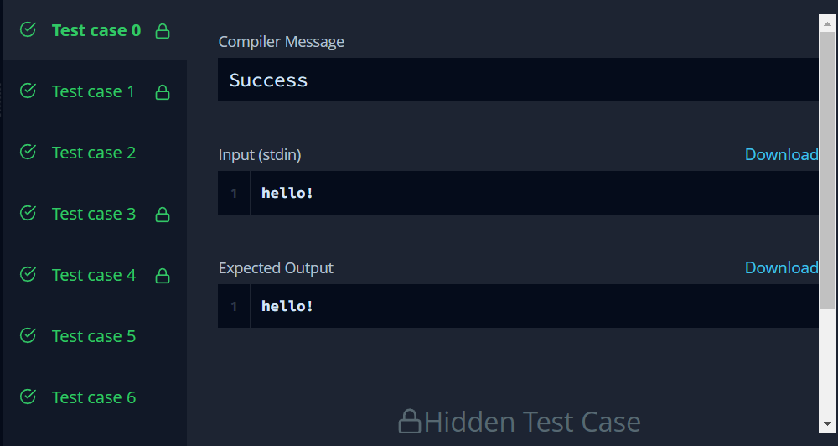

# Task-2: Balanced-forest problem

# <https://www.hackerrank.com/challenges/balanced-forest/problem?isFullScreen=true>

# Code:

#include <iostream>

#include <cstdio>

#include <vector>

#include <algorithm>

#include <string>

#include <set>

#include <map>

#include <queue>

#include <stack>

#include <deque>

#include <cassert>

#include <stdlib.h>

using namespace std;

typedef long long ll;

const ll INF = (ll) 1e18;

const int N = (int) 5e4 + 10;

vector<int> g[N];

ll c[N];

ll f[N];

ll res = INF;

ll tot = 0;

bool was[N];

void upd(ll a, ll b, ll c) {

if (a == b && c <= a)

res = min(res, a - c);

if (a == c && b <= a)

res = min(res, a - b);

if (b == c && a <= b)

res = min(res, b - a);

}

set<ll>* unite(set<ll>* a, set<ll>* b) {

if (a->size() > b->size())

swap(a, b);

for (ll x : *a) {

if (b->count(tot - 2 * x))

upd(tot - 2 * x, x, x);

if (b->count(x))

upd(x, x, tot - 2 * x);

if ((tot - x) % 2 == 0 && b->count((tot - x) / 2))

upd((tot - x) / 2, x, (tot - x) / 2);

}

for (ll x : *a) {

b->insert(x);

}

delete a;

return b;

}

set<ll>* dfs(int v) {

was[v] = true;

f[v] = c[v];

set<ll>* sv = new set<ll>();

for (int to : g[v])

if (!was[to]) {

set<ll>* sto = dfs(to);

f[v] += f[to];

sv = unite(sv, sto);

}

if (f[v] % 2 == 0 && sv->count(f[v] / 2))

upd(f[v] / 2, f[v] / 2, tot - f[v]);

if (sv->count(tot - f[v]))

upd(tot - f[v], 2 * f[v] - tot, tot - f[v]);

if (sv->count(2 * f[v] - tot))

upd(2 * f[v] - tot, tot - f[v], tot - f[v]);

sv->insert(f[v]);

return sv;

}

void solve() {

int n;

cin >> n;

for (int i = 0; i < N; i++) {

was[i] = false;

g[i].clear();

c[i] = 0;

}

tot = 0;

res = INF;

for (int i = 0; i < n; i++) {

cin >> c[i];

tot += c[i];

}

for (int i = 0; i < n - 1; i++) {

int x, y;

cin >> x >> y;

--x;

--y;

g[x].push_back(y);

g[y].push_back(x);

}

set<ll>* s = dfs(0);

//for (int i = 0; i < n; i++)

// cerr << f[i] << " ";

//cerr << endl;

delete s;

if (res == INF)

res = -1;

cout << res << endl;

// cerr << "----------" << endl;

}

int main() {

ios_base::sync_with_stdio(0);

int p;

cin >> p;

while (p--) {

solve();

}

return 0;

}

**Hacker Rank Test Case / Output:**

